Dialectal Robustness: Unpacking LLM’s Summarization and Generalization Biases in American English
- Introduction
Large Language Models (LLMs) have led to significant developments in natural language processing (NLP) tasks, however their training corpora overwhelmingly favor American English due to data availability and the geographic concentration of AI development. This imbalance raises the critical concern: models may exhibit inherent dialectal bias, leading to degraded performance and potentially the loss of cultural linguistic identity.
This project aims to evaluate and analyzes these biases within the natural language understanding (NLU) task of text summarization. The baseline standard US English will be compared to both Australian and UK English dialects to capture dialectal variants with different levels of prevalance.
Both open sourced and closed sources models will be evaluated across two core dimensions:
Generation Bias: Measuring how frequently models inadvertently shift to Americanized conventions when summarizing news articles from Australian, British, and American sources.
Evaluation Bias: Assessing performance disparities on standard benchmarks when summaries are explicitly constrained to specific regional dialects.
Ultimately, this research quantifies whether dialect choice impacts AI reliability, offering key insights for preserving cultural linguistic identity and informing user prompting practices.
- Related Works
Aditya Joshi et al. 2025 explores the inherent and diverse challenges in natural language processing stemming from dialectal variations. The paper provides a solid overall foundation for understanding and handling of dialectal variation bias specifically in reference to LLMs and the challenges of Dataset Skew & "Standard Language Bias".
Dilsiz et al. (2026) cover how contemporary languages model perform worse based on linguistics diversity. The paper focused on both Australian and Indian English but using slang as the basis of analysis for a starting point on capturing linguistic diversity assessing LLM’s ability in ‘target word selection’ and ‘target word prediction’. Their paper “evaluation highlights the limitations of LLMs to identify language variety“ and their “results underscore the need for more inclusive training data and evaluation benchmarks that account for linguistic diversity beyond standard language varieties.”

- Methodology
This section outlines the experimental design used to build the summarizations and identify generalization biases of large language models across different English dialects.
  - Datasets
We built a custom dataset of new articles from trusted news outlets from Australia, England and the United States sourced from the News API on 26 July 2026. The use of news articles was used to ensure consistent lexicographical features such as formality and context but also acted to constrain the dialect specific corpora to the same overlapping topics to account for features such as domain specific terminology . Articles were constrained to 5 key topics including artificial intelligence, elections, energy, public health and the global economy from ABC Australia, the Associated press (US) and the BBC. The dataset consisted of 10 articles per topic for each dialect resulting an entire dataset of 150 news articles total. To create the dialect identification framework and due to constraints on AI usage, 120 of these (8 per a topic) articles were used in building the Dialect Identification framework and the remaining were used for summary generation and testing the Dialect Identification framework.
  - Dialect Identification Framework
The Dialect Identification framework was created using 120 of the above articles using 3 methodologies to capture different aspects of dialect. We used the English Speller Database (ESDB) (https://github.com/en-wl/wordlist) to build python dictionaries which captures regional orthography such as the use ‘color’ vs ‘colour’.
To capture syntactic/ structural tendencies of each dialect we built POS n-gram Bayesian classifier, using spaCy's en_core_web_sm (https://spacy.io/models/en) to POS-tag each article then extracted bigram and trigram sequences of these tags as structural features. A Laplace-smoothed Naive Bayes model was fit per dialect over these n-gram frequency distributions and then performed classification via Bayes' theorem in log-space. Note quoted speech was masked before tagging, since a quote reflects the speaker's dialect rather than the reporting outlet's.
We then used fine-tuned DistilBERT (https://huggingface.co/docs/transformers/en/model_doc/distilbert) with a 3-way classification head (US/UK/AUS) on the same article corpus to capture contextual/sub word-level representations. Articles were tokenized with sliding-window overflow (32-token stride) since they exceed BERT's 512-token limit, and known outlet-specific formatting artifacts (wire-service datelines, publication boilerplate, timestamp templates) were stripped beforehand so the model couldn't learn to detect the news source instead of genuine dialect. A TF-IDF + logistic regression bag-of-words baseline was run alongside as a leakage check so that if it scored close to BERT, that would indicate the classifier was keying on surface artifacts rather than real dialectal signal.

Figure 1 below
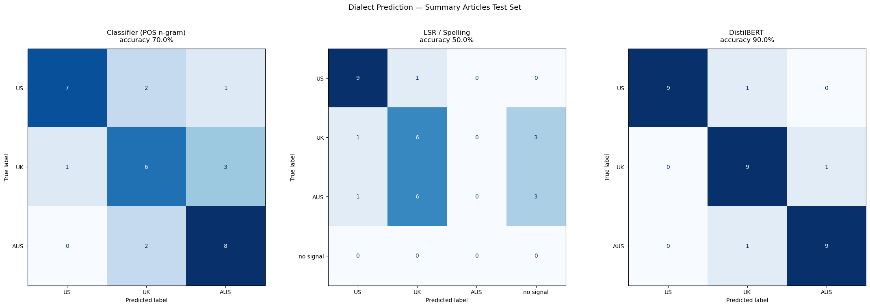
Figure 1. Effectiveness of Dialect Identification Framework on Withheld Articles
  - Task setup
Testing Generation Bias: Unconstrained summarization behavior was tested to explore to evaluate models’ tendency to favor Americanized English in the following structure.
- Summary Generation: The 30 held out articles were summarized by open source and closed source LLMs with a standard, neutral prompt
- Evaluation: The resulting summaries were processed through the custom Dialect Identification Framework.
Testing Evaluation Bias: The degradation of performance of different dialects was evaluated through performance scores of constrained generated summaries.
- Summary Generation: Open source and closed source LLMs generated 3 summaries for each of the withheld articles constrained to each specific dialect in an appropriate and professional tone.
- Evaluation: The quality of these summaries was then evaluated across metrics discussed below and averaged for a quantification of overall performance in each dialect.
Evaluation Metrics
Evaluating Generation Bias: We used the Dialect Identification Framework discussed above to quantify the rate of dialectical consistency in constrained generation summaries across spelling, syntactic/ structural tendencies and contextual/sub word-level representations language features. The 3 individual metrics allow for a deeper understanding of specifically where LLMs are deviating from dialectal form.
Evaluating Evaluation Bias: A mixture of metrics were used to quantify the overall quality over constrained dialect generated summaries due to subjectivity and metric potential biases. LLM-as-a-Judge was used using the same open source and closed source models to assign a quality score out of 10. Considering that these scores may have the same biases we then BERTscore. (https://bertscore.com ) to calculate semantic overlap with the source to quantify summarization quality. Whilst running this we utilized the dialect identification framework to ensure the constrained summaries were actually adhering to the dialectal constraints/form.

- Results
  - Generation Bias Results
The results shown in Figure 2,3 and 4 below show that in the generation bias testing task the unconstrained models largely favor producing summaries in neutral or Americanized English across both open source and closed source models.
Specifically, the spelling checker for both LLMs shows how the most objective metric of spelling is largely neutral or without dialect markers favoring no signal in over half the summaries in both models. The spelling indicators of the open source model with a signal are more evenly split between US and UK spelling whereas the close source models dialect tagged summaries more heavily favor US labels.
The posterior language detection model shows that the summaries produced largely favored generation in the US dialect. The results also show the low frequency of labels not labelled US not from alternate dialects had mixed dialectal indicators .
The BERT Classifier shows similar tendency to produce summaries in US English however shows that summaries derived from a given dialect are more purely split into either the US dialect prediction or prediction of the dialect of the article given.
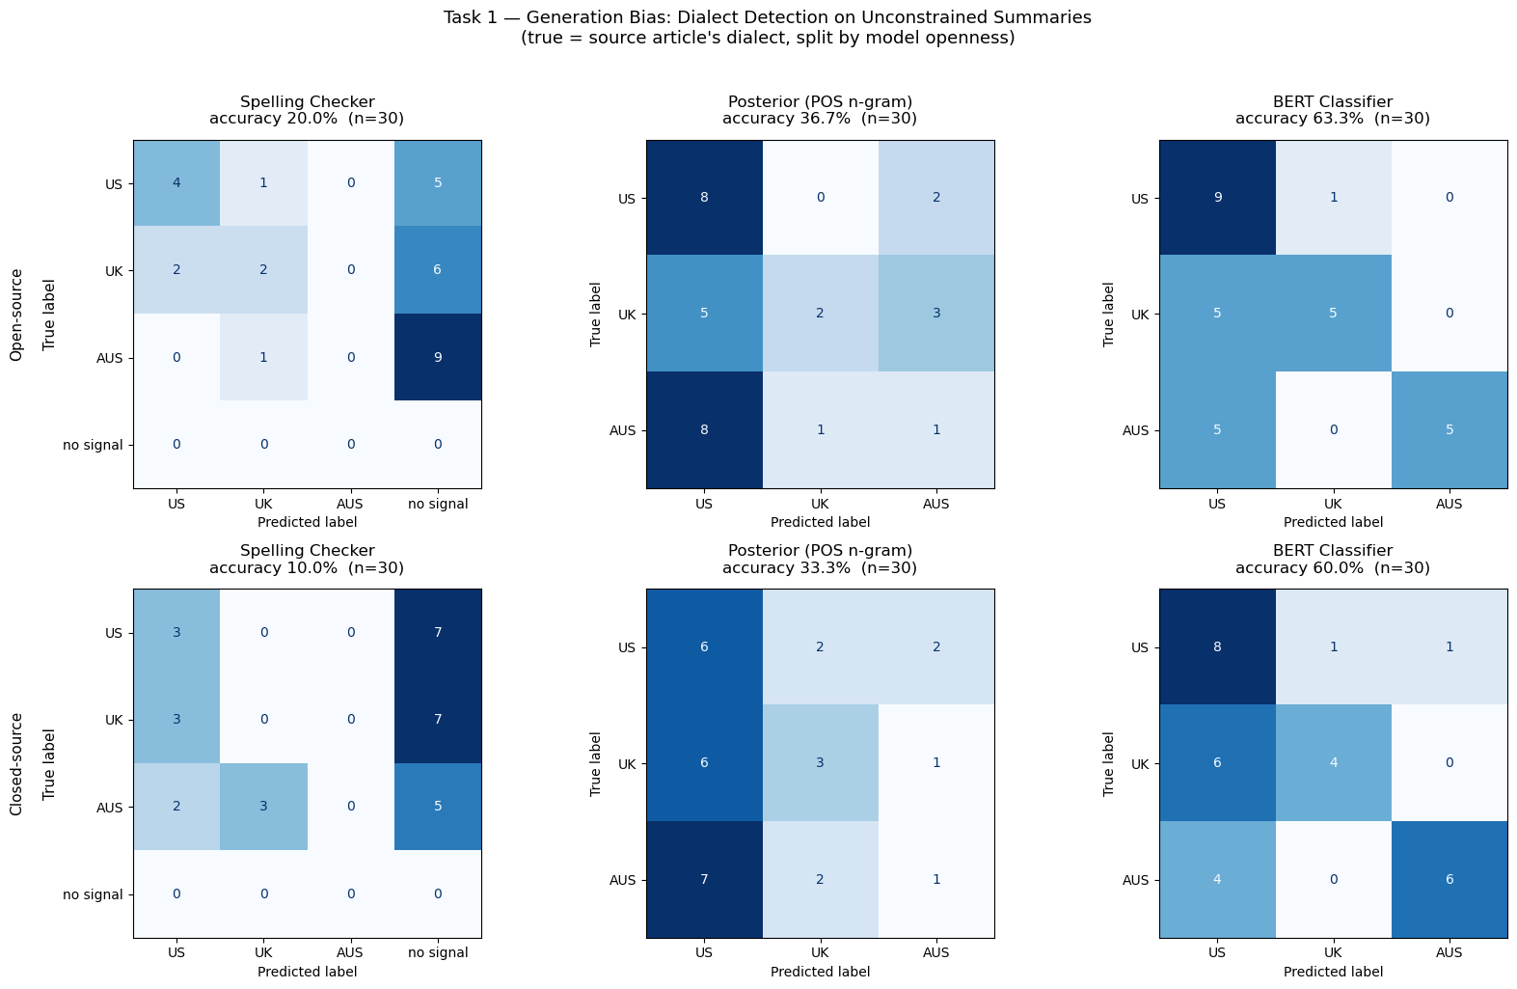

Figure 2: Generation Bias Confusion Matrix Results
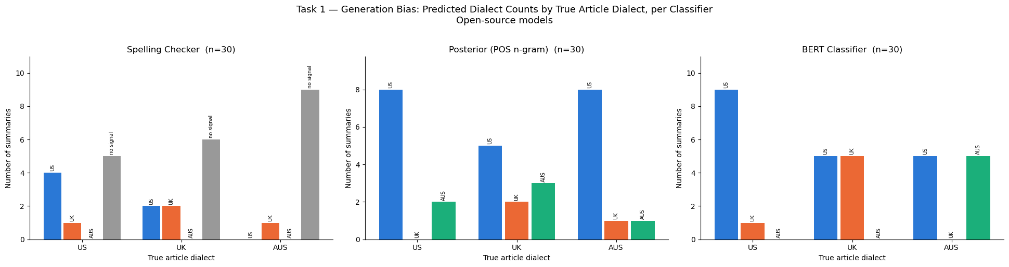
Figure 3: Generation Bias Open-Source Bar Chart Results
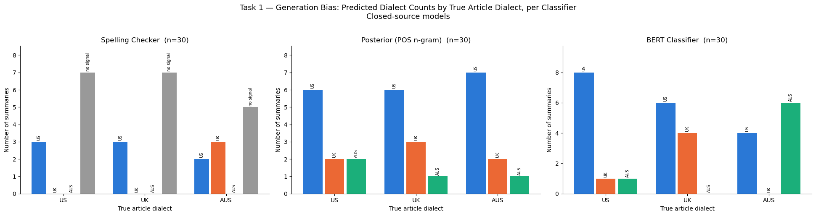
Figure 4: Generation Bias Close-Source Bar Chart Results
  - Evaluation Bias

- Discussion
The results from the generation bias testing indicate that the underlying dialect bias towards US English is present within LLM’s. The individual metrics underscore this with useful components of this bias. The spelling checker metric informs us that these models will favour language that does not provide a signal dialectal spelling variation likely as this language would appear in the cross section between all dialects potentially having the highest level of representation in the training data. Whereas both the Posterior language detection and BERT classifier indicate that less over characteristics such as syntactic/ structural tendencies and contextual/sub word-level representations still heavily favor the tendencies of US English.

- Conclusion

- Limitations
- Datasets size due to cost limitations
- Datasets themselves as measure of dialect
- Dialect Identification framework for news and not summaries
- References

